OnDemand Document Extraction:

Utilizing Blue Prism for Document Extraction Using Front-End Processes

**Background** **Information**

OnDemand holds a large amount of claims document images. These images are stored in a database that is not easily accessible for extraction. The goal of this process is to solve this issue by extracting the images by using the application directly, in a “manual” sense, and saving them as pdf files. Blue Prism, a Robotic Automation Software (RPA), is a robust, enterprise oriented screen-scraping software that follows rule-based business processes and interacts with the systems in the same way that existing users currently do. Blue Prism is the software that was used to create “bots,” hands-free processes that compose a digital workforce, in order to perform the document extraction for a reverse claims takeover. The goal of these bots is for them to be reusable for any type of OnDemand document extraction, including a long-term goal to extract all documents from the OnDemand database.

**What do the bots do?**

The goal of the Blue Prism OnDemand Document Extraction bots is to create an easy to use, hands-free method of completing and monitoring a document extraction. Given an Excel spreadsheet of inputs specific to each OnDemand folder, a bot will cycle through each input and search OnDemand for any files associated with this data. Upon discovering images, the bot will then print each found image as a pdf document, and save it within the local directory. The end result is a folder full of document pdfs. Currently, the bots can run the following OnDemand folders:

* ExPRS Production
* State Forms and eFROI
* MP-TDU
* CarePlanner and Optimed
* View Bill Image
* View EBS Data

OnDemand differs from folder to folder, so adding additional functionality requires further development, although the process for printing to pdf is universally the same.

**What do I need to do to run the bots?**

1. Configure a “Liberty Cloud Workspace” (LCW). You can login at this link: <http://lcw.lmig.com>. Once logged in, navigate to the Services Catalog tab, and then select Developer. Within this window, request “Dev – Windows 7 x32 Base.” Base Configuration is sufficient. The Business Group of the LCW should allow for admin access to files and downloads. Typically, the Information Technology (IT) Business Group is the type allowing this access, but at the time of development the Corporate (CP) Business Group was the correct type. This could be reversed by the time of execution, so further research might be necessary.
2. Download “Citrix Receiver” from the Liberty Application Portal in order to launch your newly configured LCW.
3. Download and configure Blue Prism from the Blue Prism login portal, found when googling “Blue Prism User Portal.” From the Blue Prism website, download the “v5.0.24 32-bit” release. Once you have your own copy of Blue Prism, you will have to link your application to the correct server. The process is currently being hosted on “CIClaimsRPA_local” for the connection name, and “VDDP24C-19FB72A” for the Blue Prism server. Then, you should be able to log in with your username and password.
4. You will have to request the following from the Liberty Application Portal:
   1. Adobe Acrobat Standard (the paid version is necessary to print to pdf)
   2. Microsoft .Net Framework 4.6
   3. Oracle Java SE 7 Update 55 (Includes with Java Access Bridge)
   4. LM Enterprise ID Login Manager
   5. Liberty Mutual Insurance CMIT EDM Applets
   6. IBM (OnDemand) AFP Plugin 3.5.4.1
   7. IBM (OnDemand) Client v8.4.1.1 R3
   8. OnStream Systems RapidRedact 2.03
   9. Request ‘Zephyr Passport PC to Host 19’
5. Change “.pdf” file associations to Adobe Acrobat. By default, the “.pdf” file extension will be associated with Adobe Reader. To change this, go to the start menu and open Control Panel, then click on Programs. From this window, select Default Programs and then “Associate a file type or protocol with a program.” Then scroll down the list until you find “.pdf” and change the associated program to be Adobe Standard.
6. It is recommended at this point you launch OnDemand and Adobe Standard at least once in order to ensure the applications complete their first time setup, and that they work properly. Please note that getting the proper OnDemand access is no easy task, please contact Daniel Barnes for more information.
7. You should have at the very least a basic understanding of how Blue Prism works and how to navigate to and run different processes. I recommend the “Blue Prism Foundation Training Course” pdf document which outlines and explains many of the application’s features. Note that this is not essential for running the bots, but highly recommended in case you want to modify the code.

**Once I have completed setup, how do I run the bots?**

Before running the bots, you must first create a properly formatted input spreadsheet for the bots to read from. Currently, there are two types of input spreadsheets, and which one you use is dependent on the OnDemand folder you are searching from.

The first spreadsheet is used for the ExPRS Production, State Forms and eFROI, MP-TDU, and CarePlanner and Optimed folders. The spreadsheet has two columns, the first with a header titled “Claim Number,” and the second with a header titled “Search Criteria.” For this spreadsheet, the Claim Number column will be populated with Claim Numbers, and the Search Criteria column will be populated with each Claim Number’s associated Claim ID. Here is an example:

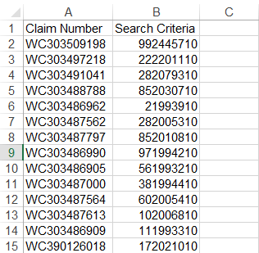

The second spreadsheet is used for the View Bill Image and View EBS Data OnDemand folders. This spreadsheet should be setup exactly the same as the other one, except the Search Criteria column should be populated with each Document Number for a given Claim Number. There should be repeated Claim Numbers in the Claim Number column if there are multiple Document Numbers for a given claim. Here is an example:

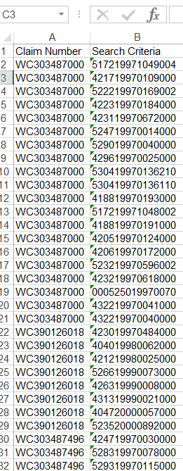

Once the input spreadsheet has been created and saved onto the Liberty Cloud Workspace that will act as a bot, actually running the bots can be done directly from the Blue Prism “Control” tab. Once this tab has been selected, the following screen should appear:

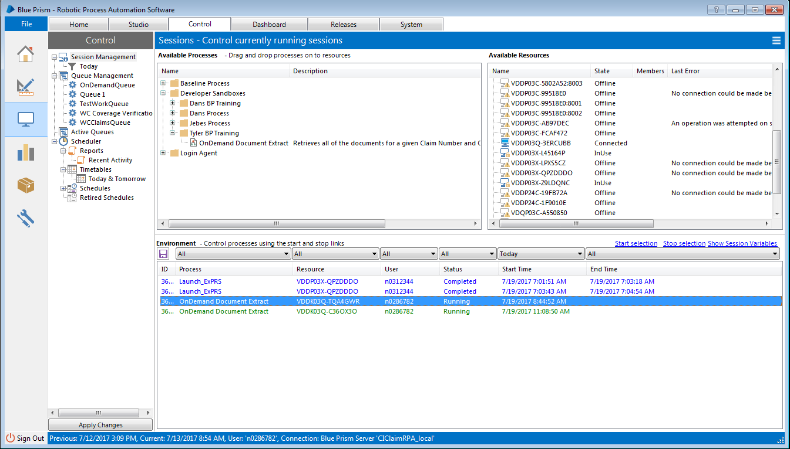

In order to run a bot, you must find the “OnDemand Document Extract” process from the folder hierarchy, and drag it over to the resource you would like to run the bot on. A Liberty Cloud Workspace will only appear as an available resource if Blue Prism is installed and running on it. Once this has been completed successfully, the process should appear as a yellow row with a “Pending” status, as shown here:

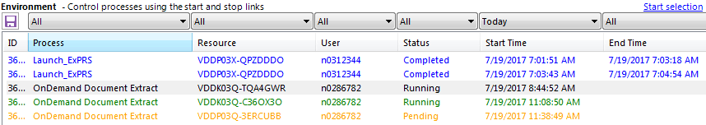

Before kicking off the bot, you must right-click the pending process, select start-up parameters, and fill out the fields with the required information. As of the initial release, the start-up parameters are as follows:

1. Excel Document File Path
   1. The Absolute Path to your properly formatted input spreadsheet.
2. Local Documents Folder Path
   1. The Absolute Path to your local documents folder
3. OnDemand User ID
4. OnDemand User Password
5. OnDemand Folder Name
   1. The case-sensitive name of the OnDemand folder you are extracting from.

Once the parameters have been saved, you then right click the process again and choose “Start Process.” Then your bot will start running!

**How do I keep track of the running bots?**

Using the Blue Prism Control Room, you can monitor the progress of the currently running bots. Once you have processes running, you can right click and select “View Log” to monitor the progress. Once opened, you can scroll through what the bot has accomplished and see how many inputs have been processed.

**NOTE: When running more than one bot, it is recommended to RDP in to the VMs you are running from instead of using Citrix Receiver. When RDP-ing in, you can choose to NOT share the clipboard with your desktop computer. This will allow for you to run multiple bots at once without them conflicting!**